1. List 5 spatial features that are present in OSM but missing/not labelled in GM.
   * 1. OSM is a volunteer-driven mapping system while Google hires cartographers to provide professional maps
     2. OSM has a humanitarian map in the options
     3. OSM regularly updates its maps while Google can take a long time to update a spot ( e.g. adding a new building)
     4. OSM allows you to change a mistake in the map
     5. OSM provides pathways and shortcuts that GM doesn’t
2. Examine the O’Brien Centre for Science, which map is more detailed, OSM or GM, what feature does GM offer that OSM does not?

The OSM is less accurate GM has a 3d view of the building which is very accurate.

1. Identify a mapping error in OSM, take a screenshot of the error and explain what is incorrect.

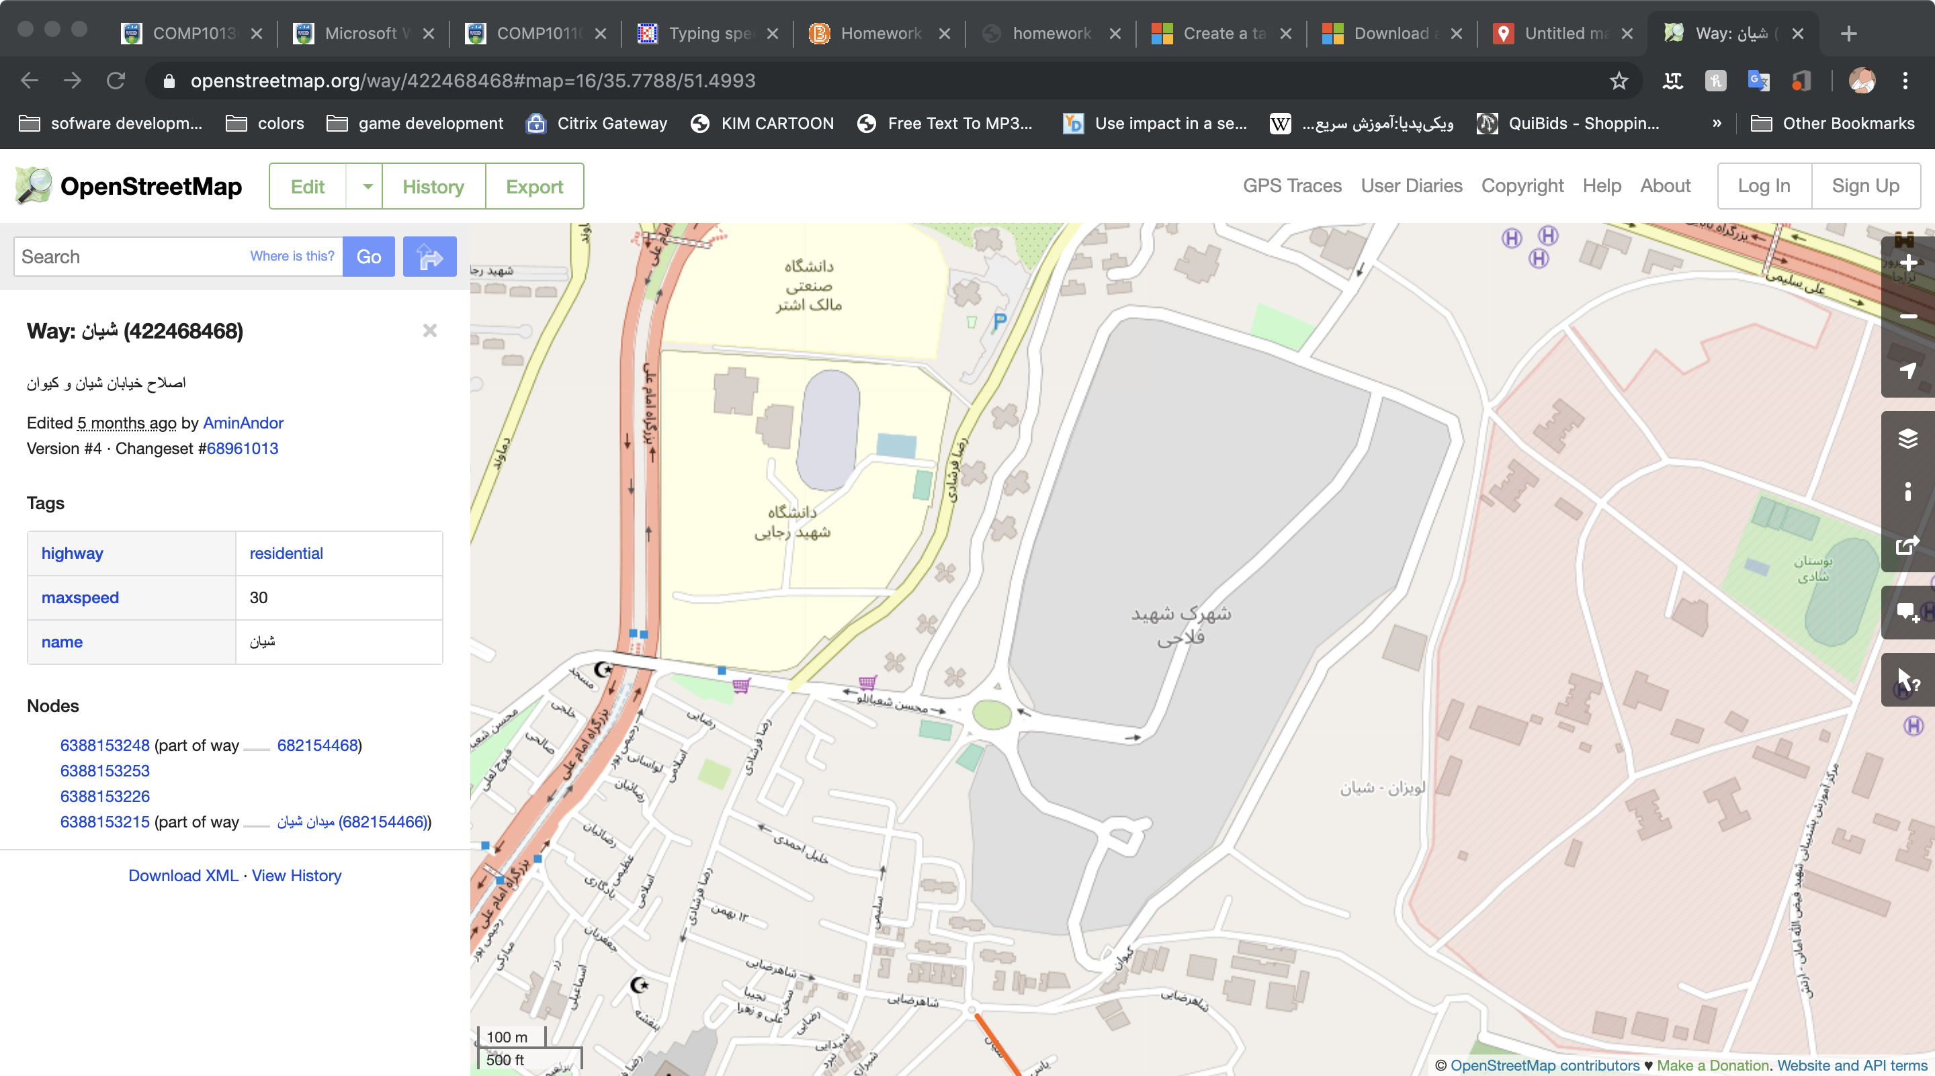

No building is represented in the red area although there are many apartments there

1. How many car parks can you identify in OSM, how many in GM?

There are 11 car parks in OSM and there are 3 in GM(including a bus terminal)

Part 2

[**Part 2 map**](https://drive.google.com/open?id=16QR95SPyrsuUpV6UJoOCWsu44ynLJOo9&usp=sharing)